**Experiment No. 4**

**Kaushal Kotkar**

**BE-15**

**Roll no: 54**

**Aim:** Utilize website crawling OSINT tools to gather a comprehensive list of URLs, internal links, and structure of the website.

**Lab outcome:** Conduct advanced searches to gather intelligence and apply advanced OSINT search techniques and tools.

**Theory:**

Website crawling OSINT (Open-Source Intelligence) tools are valuable for extracting information about a website's structure, content, and internal links. They help investigators gain insights into a website's architecture and the relationships between its pages.

Here are the tools mentioned and their roles:

1. **GetLinkInfo:** GetLinkInfo is an OSINT tool that can extract information about a website's internal and external links. It provides details such as the anchor text, target URLs, and the relationships between various pages. This tool is useful for understanding a website's linking structure.
2. **Urlscan.io:** Urlscan.io is a service that allows you to scan and analyze websites for various security and information gathering purposes. While it's primarily used for security assessments, it can provide insights into a website's structure, including the identification of subdomains, associated domains, and potential vulnerabilities.
3. **Dnsdumpster:** Dnsdumpster is an OSINT tool that focuses on DNS (Domain Name System) information. It can be used to discover subdomains associated with a target domain. Subdomains are often indicative of a website's structure, and identifying them can aid in comprehensive information gathering.

**Output GetLinkInfo**

This tool is used to extract detailed information from URLs, including title, description, external links, and redirections.

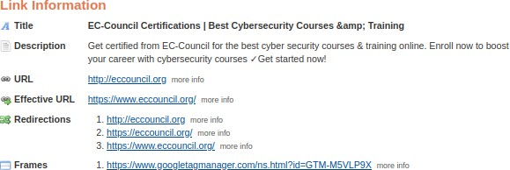

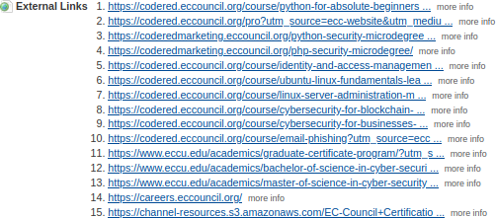

**Urlscan.io**

Urlscan.io is utilized to analyze website behavior, revealing IP addresses, TLS certificates, scanning history, and potential security threats.

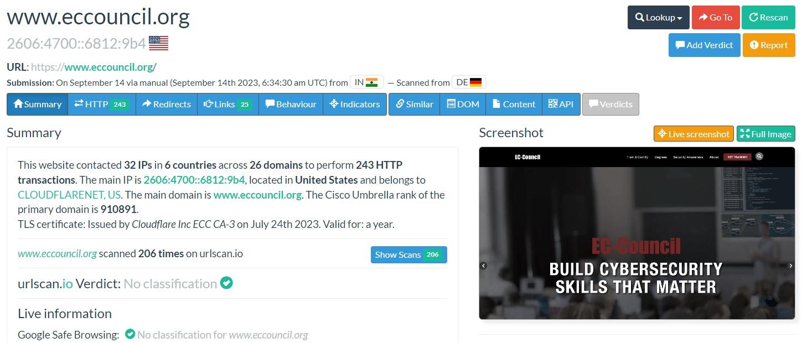

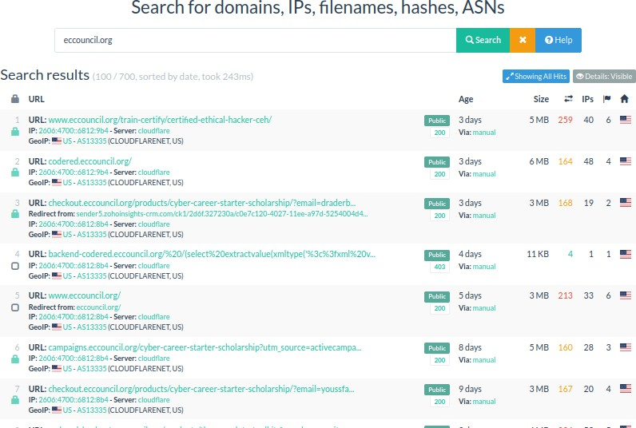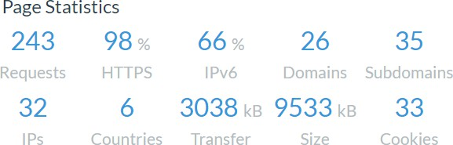

**Dnsdumpster**

Dnsdumpster helps identify IP addresses associated with domains and provides insights into domain relationships and DNS information.

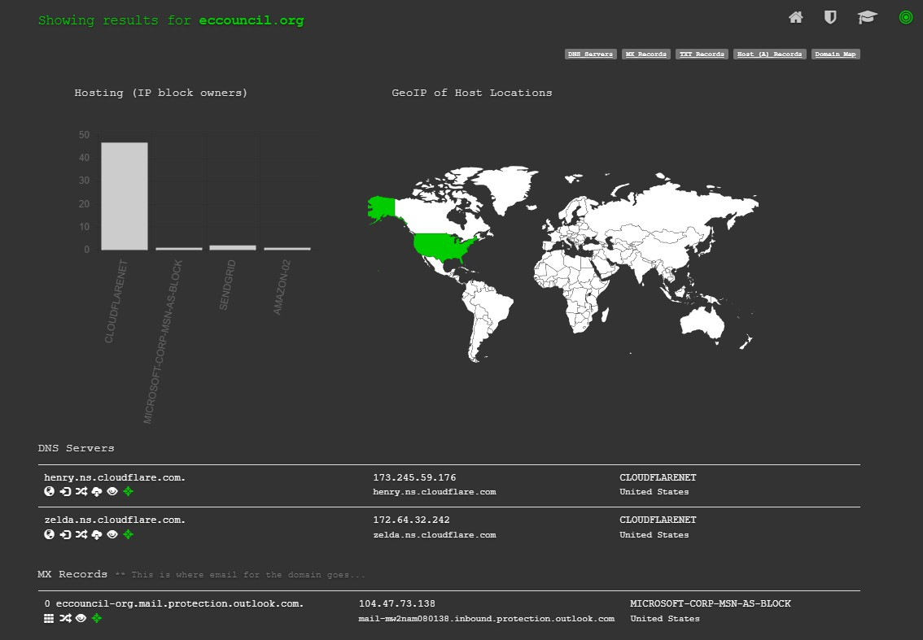

**Conclusion:**

In this process, we employed OSINT tools like GetLinkInfo, Urlscan.io, and Dnsdumpster to gather extensive information about a specific domain. These tools allowed us to compile a comprehensive list of URLs, internal links, and gain insights into the website's structure. This data is invaluable for understanding the architecture of the target website and can be useful for various investigative and analytical purposes.